

Earth’s Gravity, Weight & Mass
ICT Task 1

Learning Intention:

Success Criteria:

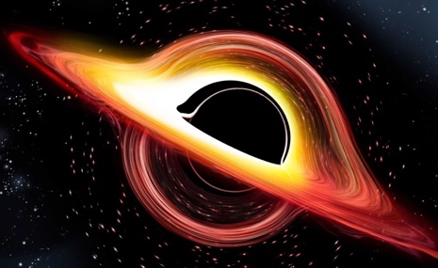

Task 1: Gravity
Got to this link: https://spaceplace.nasa.gov/what-is-gravity/en/

Answer this question: What is gravity?

Task 2: Blackholes in Space

https://spaceplace.nasa.gov/black-holes/en/

What is a black hole?

Hypothetically, if you were to take a spaceship to the edge of a black hole what would happen?

Do scientists have any evidence that blackholes exists? Research how if or any evidence has been collected. Provide a short answer on what you can find.

Task 3:
Pick a planet in the Solar System and make a 5 slide PowerPoint presentation about that planet.
Hint: Research about its discovery, composition and age to get started. You can decide on what else to research.
Include: pictures, information and interesting facts.

Submit your work via the connect submission portal.

Task 3a: The difference between weight and mass

Define the following terms?

Weight:

Mass:

Task 3b: Calculating weight on other plants

How do you calculate weight on another planet?

Why do you have a different weight on earth to other planets?

Task 3c: Comparing weights

Go to: https://theplanets.org/weight-on-planets/

Instructions: Follow the link above and input a weight of an earth brick into the computer.

Write down how much one earth brick would weigh on each of the planets listed below.

1 Earth Brick = 1.6Kg

